# Practical No.1

1 MongoDB Basics

a Write a MongoDB query to create and drop database.

Create database:

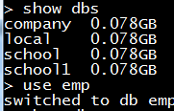



Drop Database:



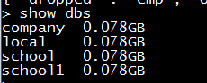

b Write a MongoDB query to create,display and drop collection

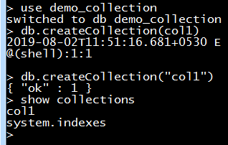

c Write a MongoDB query to insert,query,update and delete a document.

Inset Data

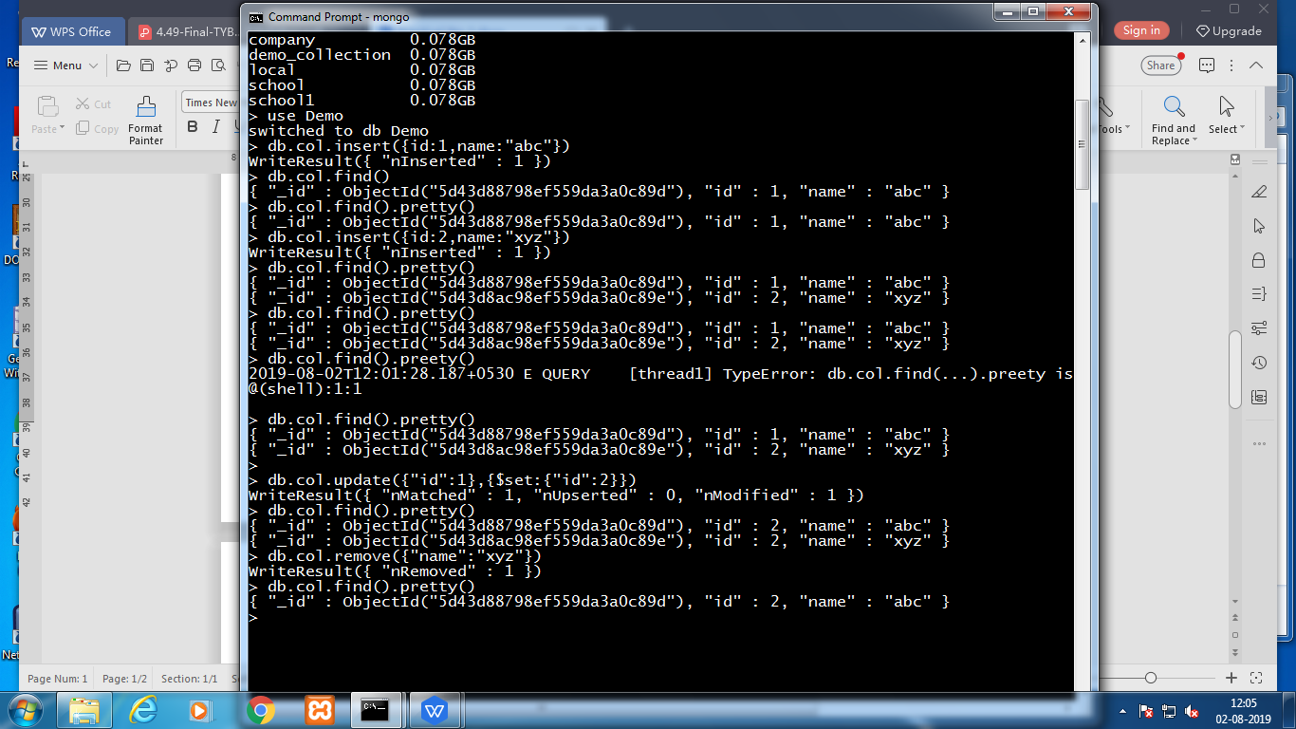



Update Data



Remove Collections

